From Sequence to Structure: Visualizing the HBB Mutation Site Responsible for Sickle Cell Anaemia
Introduction
Since we have already performed pairwise alignment using BLASTp and multiple sequence alignment using Clustal Omega, we have seen how similar the HBB sequences of primates are and how different they are from rodents. From this pairwise alignment and multiple sequence alignment, we can identify which amino acids differ between sequences, but this alone does not tell us how significant that difference actually is. A single amino acid change can sometimes have little effect, or it can drastically alter the protein's shape and function, depending on where that position is located in the 3D structure. Therefore, studying the structure of the protein is important to understand the real impact of a mutation such as Glu6Val, which causes sickle cell anaemia. In this task, the 3D structure of HBB was predicted using AlphaFold, and the position of residue 6 was examined to understand why this specific mutation has such a significant effect on the protein.
Method
We started this task by getting the PDB structure of HBB from AlphaFold DB, where we searched for HBB human or the accession P68871. AlphaFold already has predictions pre-computed for all human proteins. After downloading the PDB file, we opened it in PyMOL, where we could see the 3D molecular structure of the HBB protein.
First, we viewed the protein in cartoon form to understand its overall folded structure. Then, we selected residue 6, the site of the sickle cell mutation, and highlighted it in yellow using stick representation, so that its exact position in the protein could be seen clearly. After that, we used surface representation to check whether residue 6 was present on the outer exposed surface or buried inside the protein. Finally, to see the heme groups, which are not present in the AlphaFold predicted structure, we downloaded the experimentally solved haemoglobin structure (PDB ID: 1A3N). The four heme groups were then displayed in red, along with the protein in cartoon form.
Result
The AlphaFold-predicted structure of HBB showed a compact structure mainly made up of alpha-helices connected by short loop regions, which is similar to the known structure of
globin proteins (Figure 1). 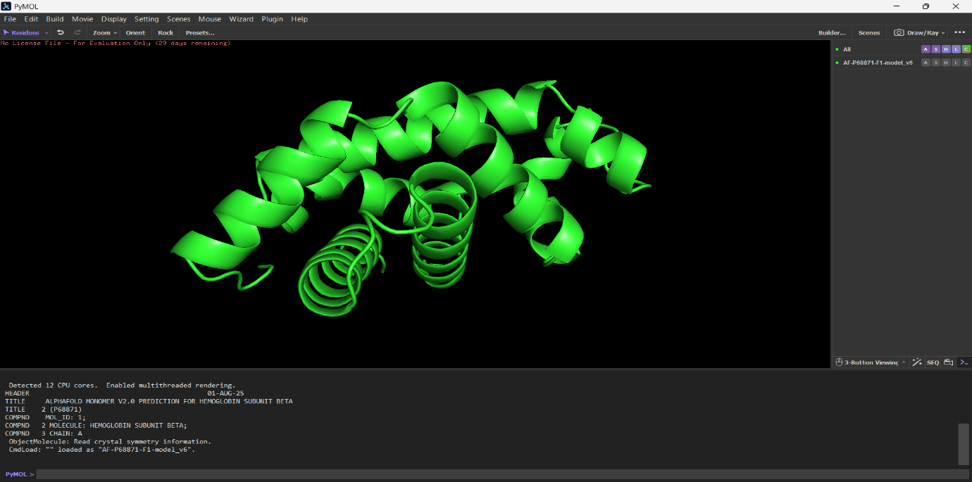
Figure 1: AlphaFold-predicted structure of HBB (cartoon view)
When residue 6 was highlighted, it could be clearly seen near the beginning of the first helix and close to the surface of the protein. It was not deeply buried inside the protein core (Figure 2).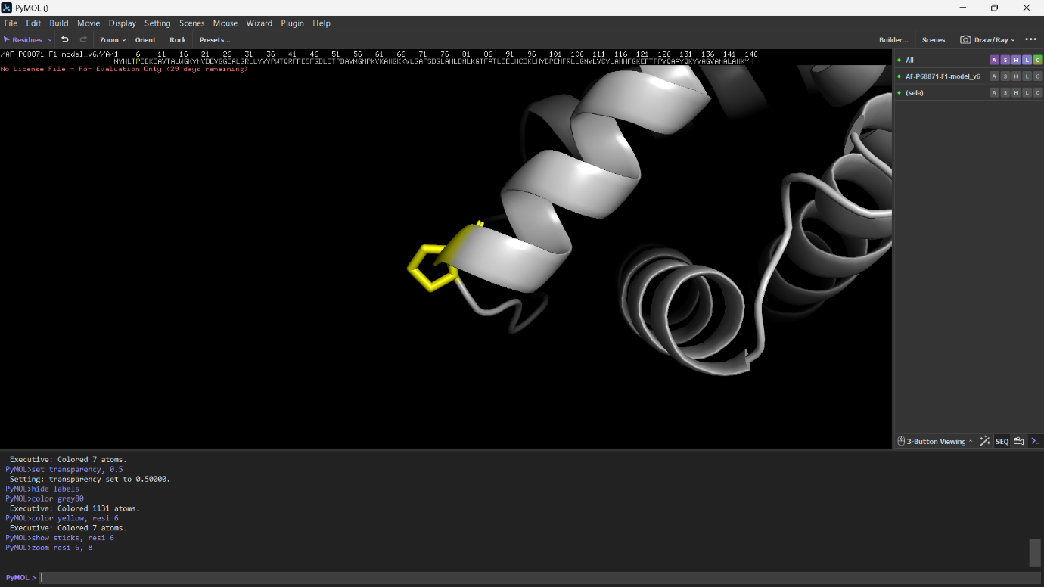
Figure 2: Residue 6 highlighted in yellow, shown as sticks
The surface representation further confirmed this, as residue 6, highlighted in yellow, appeared as an exposed region on the outer surface of the protein rather than being hidden inside it (Figure 3).
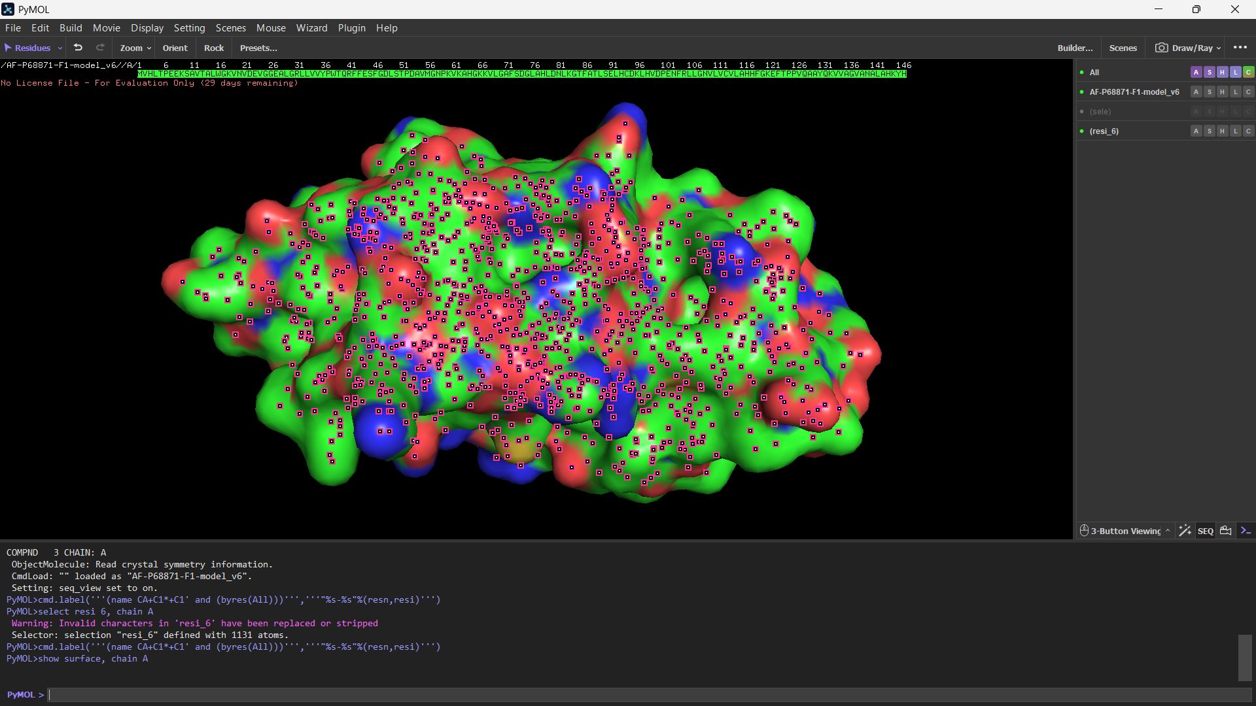
Figure 3: Surface representation showing residue 6 exposed on the protein surface
The experimentally solved structure (PDB ID: 1A3N) showed the complete haemoglobin tetramer, which consists of four subunits arranged together. Four heme groups, shown in red, were also visible, with one heme group present within each subunit (Figure 4).
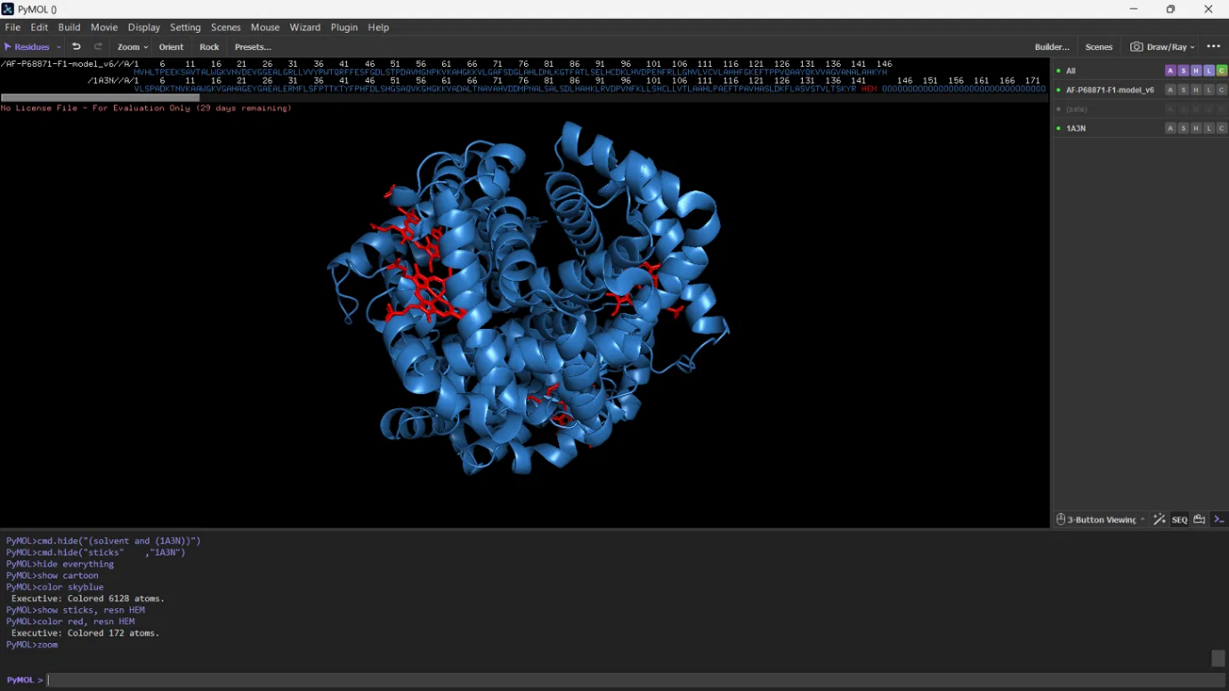
Figure 4: Experimentally solved haemoglobin structure (PDB 1A3N) showing heme groups
Discussion
The location of residue 6 on the surface of the protein is important for understanding how the Glu6Val mutation causes sickle cell anaemia. Normally, this position contains Glutamic acid, which is a negatively charged and water-attracting amino acid. Since it is present on the surface, it can interact well with the surrounding water. In sickle cell anaemia, Glutamic acid is replaced by Valine, which is a hydrophobic and water-repelling amino acid. Because Valine is exposed on the surface, it creates a sticky region that can interact with other hydrophobic regions of nearby haemoglobin molecules. As a result, the mutated haemoglobin molecules stick together and form long fibres inside red blood cells. These fibres change the normal shape of the cells and give them their characteristic sickle shape.
This structural observation also supports the conservation pattern seen in Task 2, where position 6 was found to be the same across all the primate sequences. Since this position is exposed on the protein surface, changes at this site can affect how the protein interacts with other molecules. This helps explain why position 6 has remained highly conserved.
The real haemoglobin structure (PDB ID: 1A3N) also supports the concept discussed in the Introduction. Haemoglobin functions as a four-subunit protein, with each subunit containing its own heme group for oxygen binding. This shows that HBB does not work independently but forms part of a larger structure. Therefore, a mutation in even one subunit can affect the overall function of haemoglobin.
Overall, the sequence analysis (Task 1), multiple sequence alignment (Task 2), and structural visualization (Task 3) together show how a single amino acid change, Glu6Val, can affect haemoglobin and lead to sickle cell anaemia.
Conclusion
In this task, the three-dimensional structure of HBB was predicted using AlphaFold and visualized in PyMOL to understand how the Glu6Val mutation causes sickle cell anaemia. The results showed that residue 6 is present on the exposed surface of the protein. This helps explain why replacing Glutamic acid with the hydrophobic amino acid Valine creates a sticky region, causing haemoglobin molecules to stick together and change the shape of red blood cells. The real haemoglobin structure (PDB ID: 1A3N) further showed that haemoglobin is made up of four subunits, with each subunit containing a heme group responsible for binding oxygen. Overall, this task connects the sequence analysis from Task 1 and the conservation results from Task 2 with the structural changes observed in Task 3, giving a complete understanding of how a single amino acid mutation in HBB can lead to sickle cell anaemia.

